Title of Paper

First AUTHORa,[1] and Second AUTHOR b

a Affiliation

b Affiliation

**Abstract.** Abstract goes here.

**Keywords.** Keyword, keyword

Introduction

This document provides instructions for style and layout for the ISTE Transdisciplinary Engineering Conference. It also includes information on how to submit the final version. The instructions are designed for the preparation of a camera-ready and accepted paper in MS Word and should be read carefully. Prepare your paper with a maximum length of 10 pages in the same style as used in this sample document.

Do not use numbering for the introduction chapter. For the first paragraph of a chapter or subchapter use text style “NoindentNormal”. For the rest of the paper please only use the text styles provided in this template (see Figure 1). Table 1 also gives an overview on what text styles should be used.

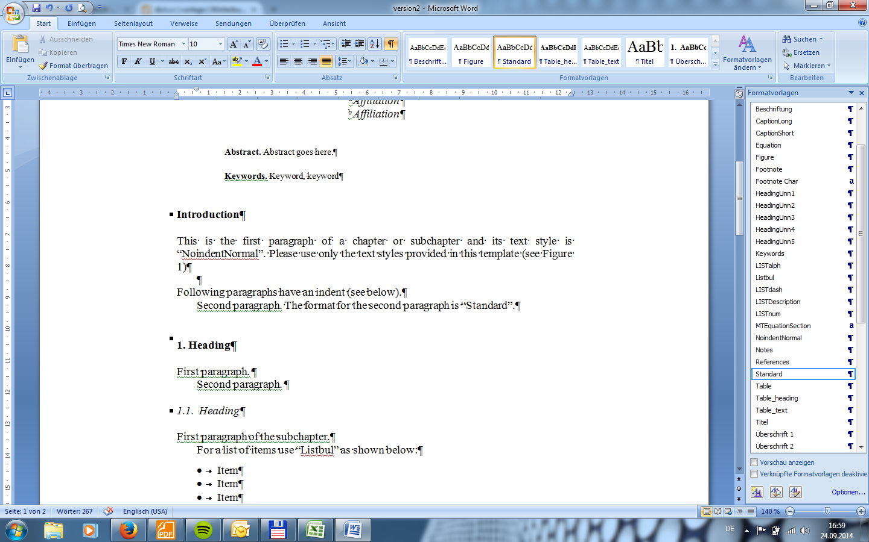

**Figure 1.** Extract of text styles provided in this template.

Following paragraphs have a small indent and the style format is “Standard”. Text. Text. Text. Text. Text. Text. Text. Text. Text. Text. Text. Text.

Text. Text. Text. Text. Text. Text. Text. Text. Text. Text. Text. Text. Text. Text. Text. Text. Text. Text. Text. Text. Text. Text. Text. Text. Text. Text. Text. Text. Text. Text. Text. Text. Text. Text. Text. Text. Text. Text. Text. Text.

**Table 1.** The styles defined in IOSPressBookArticle.

| **Style name** | **Use for** | **Short Description** |
| --- | --- | --- |
| Abstract | The Abstract | Font: 8 pt, roman. Alignment: justify. Indent: left 1.5 cm, right 1.5 cm.  Space before Abstract: 24 pt. Use bold for the word “Abstract.” |
| Affiliation | The affiliation(s) of the author(s) | Font: 10 pt, italic. Alignment: centered. |
| Author | The author(s) of your document | Font: 10 pt, roman. Alignment: centered. Use capitals for the surnames. |
| CaptionLong | Captions and legends of illustrations of more than one line | Font: 8 pt, roman. Alignment: justify. Space before 4 pt, space after 4 pt. |
| CaptionShort | Captions and legends of illustrations with more than one line | Font: 8 pt, roman. Alignment: centered. Space before 4 pt, space after 4 pt. |
| Equation | Equations | Indent: left 0.8 cm.  Space before 12 pt, space after 12 pt. |
| Footnote | Footnotes | Font: 8 pt, roman. Alignment: justify. |
| Heading 1 | The first level headings | Font: 10 pt, bold. Alignment: left.  Space before 24 pt, space after 12 pt.  Do not hyphenate. |
| Heading 2 | The second level headings | Font: 10 pt, italic. Alignment: left.  Space before 12 pt, space after 12 pt. Do not hyphenate. |
| Heading 3 | The third level headings | Font: 10 pt, italic. Alignment: left.  Space before 12 pt, space after 6 pt. Do not hyphenate. |
| Heading 4 | The fourth level headings | Font: 10 pt, italic. Alignment: left.  Space before 6 pt. Do not hyphenate. |
| HeadingUnn1 | First level unnumbered heading. Use for the Introduction, Acknowledgements, Appendix, Notes, References | Font: 10 pt, bold. Alignment: left.  Space before 24 pt, space after 12 pt.  Do not hyphenate. Unnumbered. |
| HeadingUnn2 | Secondary unnumbered heading | Font: 10 pt, italic. Alignment: left.  Space before 12 pt, space after 12 pt.  Do not hyphenate. Unnumbered. |
| Keywords | The keywords | Font: 8 pt, roman. Alignment: justify. Indent: left 1.5 cm, right 1.5 cm.  Space before Keywords: 12 point. Use bold for the word “Keywords.”. |
| LISTbul | Unnumbered lists, with bullit | Font: 10 pt, roman. Indent: left 0.63 cm. Indent: hanging: 0.63 cm. |
| LISTdescription | Unnumbered list with description | Font: 10 pt, roman. Indent: hanging 0.8 cm |
| LISTnum | Numbered lists | Font: 10 pt, roman. Indent: left 0.63 cm. Indent: hanging: 0.63 cm. |
| NoindentNormal | The first paragraph of running text after headings. | Font: 10 pt, roman. Do not indent first line. |
| Normal | Running text | Font: 10 pt, Times New Roman. Alignment: justify. Indent first line: 0.63 cm. |
| Notes | Endnotes | Font: 8 pt, roman. Alignment: justify. |
| References | Bibliographic References, CitationSequence System | Font: 8 pt, roman. Alignment: justify. Indent: hanging 0.63 cm. |
| Table | The table text | Font: 8 pt, roman. Alignment: left |
| Title | The title of your document | Font: 20 pt, roman. Alignment: centered. Space before: 24 pt, space after 16 pt. |

# First numbered Heading

First paragraph.

Second paragraph.

Third paragraph.

Fourth paragraph.

## Bullet lists and enumerations

First paragraph of the subchapter.

For a list of items use “Listbul” as shown below:

* Item
* Item
* Item

Following paragraph with normal text. For a numerical list please use “LISTnum” as shown below:

1. First Item
2. Second Item
3. Third Item

The text after each list always continues with “Standard” text style. Other ways to make a list is shown below (“LISTDescription”):

Description. This is an example for a list without bullets. Text. Text. Text. Text. Text. Text. Text. Text. Text. Text. Text. Text. Text. Text. Text. Text. Text. Text.

Description #2. Text. Text. Text. Text. Text. Text. Text. Text. Text. Text. Text. Text. Text. Text. Text. Text. Text. Text.

Dash #3. Text. Text. Text. Text. Text. Text. Text. Text. Text. Text. Text. Text. Text. Text. Text. Text. Text. Text.

Text after the list of descriptions.

# Footnotes

When a word/phrase needs further explanation please use footnotes. The text in the footnotes is formatted with “Footnote”.[2]

# Formatting figures and tables

The text should include references to all illustrations. Do not collect illustrations at the back of your article, but incorporate them in the text. Tables and figures should be positioned with at least 2 lines extra space between them and the running text. Regarding the quality of illustrations, please avoid using illustrations taken from the Web. The resolution of images intended for viewing on a screen is not sufficient for the printed version of the book. If you are incorporating screen captures, keep in mind that the text may not be legible after reproduction. Illustrations will only be printed in color if the volume editor agrees to pay the production costs for color printing. The color in illustrations will be retained in the online (ebook) edition. Check that all the text and illustrations are inside the type area and that the type area is used to the maximum.You may of course end a page with one or more blank lines to avoid ‘widow’ headings, or at the end of a chapter.

## How to format figures

First, if you want to make use of figures please insert an empty line formatted with the text style “Figure”. Then insert the figure. Figure 2 shows an example of what the formatted figure should look like. The text style of the figure’s caption is “CaptionShort”.



**Figure 2.** Example of a figure with full width (12.4cm).

The text after the figure is formatted as “Standard”. Now, an example for the reference of a figure: Figure 2 shows a rectangle with black lines and white filling. Figure 3 presents a scaled figure with reduced width.



**Figure 3.** Example of a scaled figure (width 6.2cm).

There are also other ways to place the figure. It may be more convenient in case of large and narrow figures to have text and figure parallel to each other. Here is an example for using a figure and a text next to each other (Figure 4):

|  |  |
| --- | --- |
| Text. Text. Text. Text. Text. Text. Text. Text. Text. Text. Text. Text. Text. Text. Text. Text. Text. Text. Text. Text. Text. Text. Text. Text. Text. Text. Text. Text. Text. Text. Text. Text. Text. Text. Text. Text. Text. Text. Text. Text. Text. Text. Text. Text. Text. Text. Text. Text. Text. Text. Text. Text. Text. Text. Text. Text. Text. Text. Text. Text. Text. Text. Text. Text. Text. Text. Text. Text. Text. Text. Text. Text. Text. Text. Text. Text. Text. Text. Text. Text. Text. Text. Text. Text. Text. Text. Text. Text. Text. Text. Text. | **Figure 4.** Short description of figure. |

Afterwards the text continues with text style “Standard”. It is also possible to align the figure on the left hand side as shown in Figure 5.

|  |  |
| --- | --- |
| **Figure 5.** Short description of figure. | Text. Text. Text. Text. Text. Text. Text. Text. Text. Text. Text. Text. Text. Text. Text. Text. Text. Text. Text. Text. Text. Text. Text. Text. Text. Text. Text. Text. Text. Text. Text. Text. Text. Text. Text. Text. Text. Text. Text. Text. Text. Text. Text. Text. Text. Text. Text. Text. Text. Text. Text. Text. Text. Text. Text. Text. Text. Text. Text. Text. Text. Text. Text. Text. Text. Text. Text. Text. Text. Text. Text. Text. Text. Text. Text. Text. Text. Text. Text. Text. Text. Text. Text. Text. Text. Text. Text. Text. Text. Text. Text. |

It is also possible to put two figures next to each other (Figure 6 and Figure 7).

|  |  |
| --- | --- |
| **Figure 6.** Right figure. | **Figure 7.** Left figure. |

## How to format tables

In this section the formatting and referencing of tables is briefly explained. Please make sure that the tables you are using are formatted as seen in Table 2.

**Table 2.** Long captions are justified. Long caption. Long caption. Long caption. Long caption. Long caption. Long caption. Long caption. Long caption.

|  |  |  |
| --- | --- | --- |
| **Column1** | Column2 | **Column3** |
| –10.2 | 10.2 | 10.2 |
| 5.36 | 6.32 | 6.32 |
| –5.7 | 5.7 | 0.326 |

The text after the table is formatted with “Standard (after tables)”. The paragraph afterwards is however formatted with “Standard”.

So here is the regular Paragraph with some more random text.

# How to insert an equation

When you want to insert an equation please don’t use the embedded Formula Editor. Instead make use of the Microsoft Formula Editor 3.0 (see Figure X).

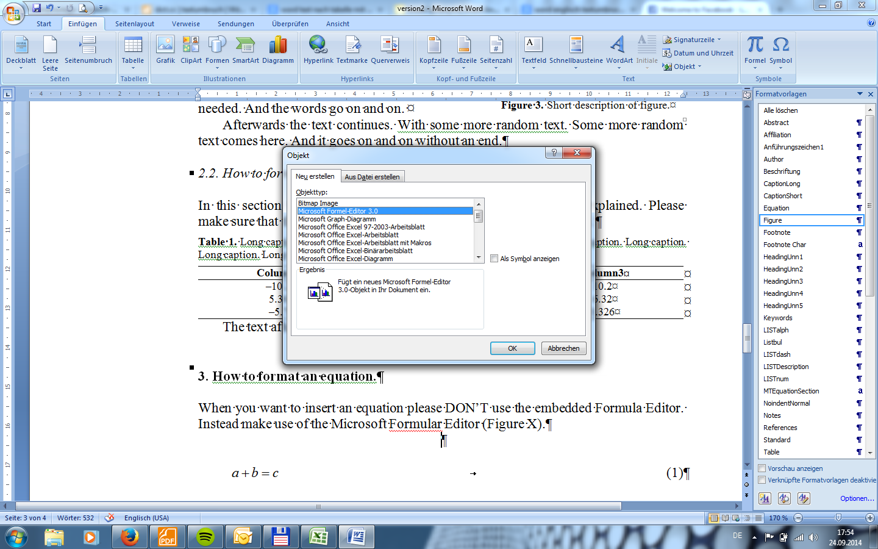

**Figure X.** How to access the Microsoft Formula Editor.

A simple formula expressing that the sum of *a* and *b* equals *c* should look like Equation 1. Its text style is “Equation”. Remember to number all the equations in ascending order as they appear in the text.

 (1)

Text style after equation is “Standard”. Here a more complex example of a formula from [1]:

 (2)

# How to make a proper reference

When making a reference to sources please use numbers and square brackets. Make sure that the references are numbered in the order in which they first appear in the text (Citation Sequence style).

* [2] is a reference to a textbook.
* [3] is a reference to a journal paper.
* [4] is a reference to a chapter that was contributed to a book.
* [5] is an example for an internet source.
* [6] refers to a standard.
* [7] shows the format of a conference paper.

# General instructions

## Papersettings

Using this template you should use A4 for the paper size setting, not letter size. Otherwise it will affect the resulting type area.

## Submission of your article

Submit the following to the volume editor:

1. MS Word document;
2. Identical high resolution PDF file with all fonts embedded. We recommend Adobe Acrobat Distiller and the job option “Press-Optimized”.)

Concerning the item about submitting a PDF with the Word document (or source file), note that IOS Press processes the PDF file, and only falls back on the Word document, if necessary. Both should be submitted, identical versions, and the PDF in the format specified. If volume editors create the PDF files, there is a risk of errors, because of missing fonts, and so on.

Acknowledgement

This section is optional. Title style is the “HeadingUnn1” for the section and “HeadingUnn2”, etc. for the following subsections.

References

[1] Y.-H. Wang, P.-C. Kuo and T.-H. Chow, Using Patent Co-Citation Approach to Explore Blue-ray Technology Classifications, In J. Cha et al (eds.): *Moving Integrated Product Development to Service Clouds in the Global Economy,* Vol. 1,pp. 153-161, 2014.

[2] A.N. Author, *Book Title*, Publisher Name, Publisher Location, 1995.

[3] A.N. Author, Article title, *Journal Title,* Vol.66, 1993, pp. 856–890.

[4] A.N. Author 1 and A.N: Author2, Title of Chapter Contributed, In A.N. Editor et al. (eds.): *Title of Book,* Publisher Namer, 5th ed, Publisher Location, Year, pp. XXX-XXX.

[5] A.N. Author/Instituation, Year, *Website name/title*, Accessed: DD.MM.YYYY. [Online]. Available: <http://www.website.com/>

[6] *Title of Standard,* Number of standard, date.

[7] A.N. Author1, A.N. Author 2 …and A.N. Author n, Title of conference paper, In: *Name of Conference,* City, Year, pp. XXX-XXX.

1. Corresponding Author, Mail: [Enter here the corresponding author’s E-Mail address].
2. This is the footnote text. Text. Text. Text. Text. Text. Text. Text. Text. Text. Text. Text. Text. Text. Text. Text. Text. Text. Text. Text. Text. Text. Text. Text. Text. Text. Text. Text. Text. Text. Text. Text. Text. Text. Text.